Synergistic enhancement effects of combined antimicrobial therapies to reduce antibiotic resistance
Jennifer M. Soares^{1,}*, Francisco E. G. Guimarães¹, Vladislav V. Yakovlev²,
Vanderlei S. Bagnato^{1,2}, and Kate C. Blanco¹.
¹ São Carlos Institute of Physics, University of São Paulo – São Carlos - SP, Brazil
² Biomedical Engineering, Texas A&amp;M University - College Station - TX, USA
*Corresponding author: Av. Trabalhador São-carlense, 400, São Carlos, São Paulo, Brazil,
Postal code: 13566-590, +55 (16) 3373-9810, Fax: 3373-9811. Email: jennifer.soares@usp.br

ABSTRACT
The antibiotic failure in resistant bacterial infections is one of the major global health challenges in our present civilization. Alternatives that destroy the bacterial resistance may become susceptive to regular antibiotics will be the solution for the problem. For that, combined techniques can be the solution. However, the combination therapies such as antibiotic therapy and photodynamic inactivation is not trivial due to the different parameters, which can modulate the synergistic response. The aim of this study is to potentialize the antimicrobial action of antibiotics in sensitive and resistant strains in presence of reactive oxygen species in the microorganism environment. Subdose photodynamic inactivation protocols combined with antibiotics were evaluated, varying the application sequence and time intervals. We studied the dynamics of interaction between Staphylococcus aureus and the curcumin photosensitizer and the antibiotics amoxicillin, erythromycin, and gentamicin. As a result of the antibiotic potentializing effect by photodynamic inactivation, the combined groups present bacterial reduction superior to the monotherapies. In addition, the interaction between therapies was dependent on the sequential order of application of them, affects the metabolic activity and binding of cell surface bacterial biomolecules. This evidence highlights the ability of combination therapies as a strategy to the fight of antibiotic-resistant bacterial infections.
Keywords:

- INTRODUCTION
According to the World Health Organization (WHO) bacterial infections affect hundreds of millions of people worldwide every year, with some cases resulting from outbreaks and healthcare-associated infections (HAIs). Staphylococcus aureus is one of the main opportunistic human pathogens causing infections of skin, mucous membranes, endocarditis, pneumonia and, bacteremia in adverse conditions and sometimes resulting in fatal conditions. ¹ Several resistant, tolerant, and persistent strains are able to survive in the presence of antibiotics resulting in treatment failure of infections ². Antibiotic failures affect nearly 180 million people worldwide, with a predicted increase to 225 million by 2030. However, the insertion of new antibiotics in the market has been decreasing over the years due to the search for new antimicrobials to bring low profits to the pharmaceutical industry, so new strategies for the treatment of infections are necessary ^{3,4}. This prediction precedes the mass use of antibiotics for the treatment of patients infected with SARS-CoV-2, who had the wrong prescription of this drug, since the cases of co-infection of the virus with bacteria are less than 4%, without a doubt. the global scenario of bacterial resistance to antibiotics may have been accelerated. Antibiotic therapy remains the gold standard for the treatment of infections, although there is an increase in cases of antibiotic-resistant and persistent bacteria in chronic cases ⁵.
The combination of treatments may be an alternative to overcome this limitation. Unlike antibiotic therapy the Photodynamic Inactivation (PDI) is based on the specific interaction of the drug with biological targets such as occurs in bacteria⁶, PDI promoting its death by oxidative stress in multiple cellular structures, preventing the development of resistance after PDI 7⁷. The mechanism-based PDI is the reactive oxygen species (ROS) production results in the photon absorption by photosensitizer (PS), capable of promoting an electron from the ground state (S0) to the excited singlet state (S1), which has high probability of transitioning to the triplet excited state (T1). The interaction of PS with O₂ can occur through two types of reaction called type I and type II ^{8,9}. In the type I reaction, PS in the T1 state transfers electrons to organic substrates or biomolecules, forming radical ions that tend to react with molecular oxygen, resulting in ROS such as hydrogen peroxide (H₂O₂), superoxide anion radical (O₂−) and hydroxyl (−OH). In contrast, in the type II reaction, PS in the T1 state transfers energy directly to molecular oxygen, through molecular encounter, exciting it to its highly reactive singlet state (¹O₂). All ROS react with proteins, lipids and nucleic acid promoting bacterial cell death ^{3,10}. This is how in Figure 1.A Clinical trial and in vitro studies are carried out showing the PDI effectiveness for infections being superficial, internal and prevention such as pharyngotonsillitis ²⁹, pneumonia³⁰ or in endotracheal tubes ³¹

Antibiotic therapy and PDI act by a different mechanism to inactivate bacteria when combined. The ROS presence from PDI may cause synergistic effects during antibiotic treatment potentiating the treatment action¹¹. This study evaluated the interaction of curcumin PS with three different conventional antimicrobials, amoxicillin (AMO - β-lactam that inhibits cell wall synthesis)¹², erythromycin (ERY- macrolide) and gentamicin (GEN - aminoglycosides) which inhibit protein synthesis by acting on the 50S and 30S subunits of the ribosome, respectively^{13,14}. We propose to observe how different combination protocols can affect the interaction between antimicrobial molecules and PS on Staphylococcus aureus. And thus, seek consistent results which demonstrate the potential for clinical application of combined therapies. The main long-term goal is to identify alternatives to make antibiotic-resistant bacteria returns to original properties of non-resistance. Thus, PDI can be an adjunct to antibiotic therapy, prolonging the use of antibiotics available on the market.

- METHODOLOGY

2.1 MICRO-ORGANISM CULTIVATION
The Staphylococcus aureus (ATCC 25923) was cultivated in Brain Heart Infusion Agar (BHI) for 24 h. Colonies were suspended in phosphate buffered saline (PBS) for PDI in antibiotic-containing treatments, and were suspended in Mueller Hinton (MH) medium. The inoculum was adjusted to 10⁸ CFU/ml at 600 nm (Cary UV-Vis50, Varian) and was inoculated into confocal dishes for 24h at 37°C in BHI medium to obtain the confocal microscopy images.

2.2 PHOTODYNAMIC INACTIVATION
The stock solution of the PS: synthetic curcumin (PDTPharma®) was prepared in 5 mM ethyl alcohol and diluted in distilled water at the concentrations of interest. Three control groups were performed: General Control (bacteria), Dark Control (bacteria + PS), Light Control (bacteria plus light) and the PDI treatment group (bacteria + PS + light). For the PDI and dark groups, the bacteria were incubated with 10 μM of curcumin for 15 min. Subsequently, the light and PDI groups were submitted to a light dose in the range of 5 to 80 J/cm² using the 450 nm LED device (Biotable® - produced by MM Optics - Brazil). The samples were seeded in Petri dishes to count the surviving colony forming units per milliliter (CFU/ml).

2.3 MINIMUM INHIBITORY CONCENTRATION
The experiments were performed according to the recommendation of the Clinical and Laboratory Standards Institute (CLSI) ¹⁵. The antimicrobial agent’s amoxicillin (AMO), erythromycin (ERY) and gentamicin (GEN) were distributed in 96-well plates by means of sequential dilution and subsequently the bacterial inoculum with standardized concentration was added. A positive control of bacterial growth and a negative control of the culture medium were performed together, the plate was stored at 37 °C for 24 hours. Subsequently, the resazurin solution (0.002%) was added for 4 hours at 37 °C. The minimum inhibitory concentration (MIC) was defined as the lowest concentration of the antibiotic capable of inhibiting the visible growth of bacterial strains. In the MIC study after PDI, the only change is the inoculum added which corresponds to the bacteria initially treated following the protocol described in previous session. Conditions below the PDI dose threshold were used for the combination experiments, ensuring bacterial cell survival.
2.4 COMBINATION OF PHOTODYNAMIC INACTIVATION AND ANTIBIOTIC THERAPY
Oxidative stress - The first treatment applied to S.aureus followed the protocol described previously. The bacteria were incubated in the presence of 10 μM of curcumin for 15 min and subsequently irradiated at 10 and 20 J/cm². Surviving bacterial cells were added to MH medium containing antibiotic AMO, ERY, GEN at different concentrations for 24 h at 37 °C. Subsequently, the samples were diluted and plated on BHI agar medium for colony counting after 24 h.
Simultaneous internalization - The bacterial inoculum was incubated at 37 °C in the presence of 10 μM of curcumin and different concentrations of antibiotic in MH for 15 min. Subsequently irradiated at 10 and 20 J/cm² and after 24h of incubation at 37 °C, the samples were diluted and plated on BHI agar medium for colony counting after 24 h.
2.5 PERMEABILITY OF THE CYTOPLASM MEMBRANE
The protocol applied to evaluate the permeabilization of the cytoplasmic membrane by measuring the absorbance of extracellular genetic material was adapted from Siriwon et al ¹⁶. The S.aureus bacterium was submitted to the PDI treatment described. After treatment, samples were collected and filtered through a sterile nitrate cellulose membrane (0.22 µm) and the absorbance of the supernatant was measured at 260 nm (Cary UV-Vis50, Varian).
2.6 TREATMENT CYCLE
Two protocols were applied for cyclic treatments combining PDI and ANTB.
Concomitant cycle: the bacteria were incubated with 10 μM curcumin for 15 min and subsequently irradiated with 10 J/cm² at 450 nm by Biotable®. Then the cells were suspended in MH containing antibiotic AMO, ERY, GEN separately under previously established MIC conditions and incubated at 37°C for 6 hours. Subsequently, the cells were washed and samples collected for plating and determination of CFU/ml. Washed cells were subjected to this protocol for an additional 5 cycles.
Alternating cycle: At time 0h the bacteria were incubated with 10 μM curcumin for 15 min and then irradiated with 10 J/cm² at 450 nm by Biotable® and the surviving cells were suspended in MH only and incubated at 37 °C for 6 hours. Subsequently, the cells were washed and samples collected for plating and determination of CFU/ml. Washed cells were suspended in MH containing antibiotic AMO, ERY, GEN separately under previously established MIC conditions and incubated at 37°C for 6 hours. The procedure was repeated for a total of 30 hours, and at times 0, 12, 24 hours S. aureus received PDI and at times 6 and 18 hours antibiotic therapy.
2.7 FOURIER TRANSFORMATION INFRARED SPECTROSCOPY
The samples plated from the treatment cycle (2.6) at 37 °C for 24 hours, had the colonies collected for analysis on the Attenuated Total Reflection (ATR) Fourier Transform Infrared (FTIR) equipment. Agilent Cary 630 FTIR Spectrometer®. The bacterial colony was evenly distributed over the crystal surface. The dry sample was scanned 250 times and the result was the average of the measurements. The FTIR spectrum was measured in the range of 4000 to 650 cm⁻¹. Measurements were performed on three different samples. The resulting spectrum of bacteria was submitted to the calculation of the second derivative, then to normalization by minimum-maximum and the data submitted to hierarchical cluster analysis by Origin.¹⁷

2.8 CONFOCAL MRICOSCOPY ANALYSIS
An inverted Zeiss LSM 780 confocal laser scanning microscope (CLSM) with a Coherent Chameleon laser (Ti:sapphire) as a two-photons (2P) excitation source tuned to a wavelength of 800 nm was used in the experiments with laser pulse at 80 MHz. The images were collected in spectral mode and channel modes with an objective lens (63×, 1.2 numerical aperture, water immersion). Planktonic bacterial cells were conditioned in sterilized confocal dishes and maintained at 37°C at 7% CO₂. The final measurement water volume for each well was 200 μl. Cell viability was measured using the LIVE/DEADTM reagent with 2-photon excitation at 800 nm in channel mode, fluorescence was captured between 415 and 540 nm for acridine orange and 580 to 620 nm for ethidium bromide. The experiments were carried out in the case of viability above 90%. The optical setup was adjusted to the best signal-to-noise ratio and fixed when different samples were compared.
Fluorescence Lifetime Imaging (FLIM): For FLIM experiments, the 2P laser was pulsed at 80 MHz. The fluorescence was divided by a beam splitter in two detecting channels of a PicoQuant GmbH system detecting the fluorescence between 500 and 550 nm. The method used was the time correlated single photon counting (TCSPC) using an avalanche detector, which has a time response limited at about 100 ps. Two-exponential fit was used to adjust the fluorescence decay data. The choice of the fitting range was set by the software program (Time Trace Analysis by PicoQuant GmbH) by considering the decay part of the time dependent data according to optimal parameters.
Photosensitizer uptake: The average laser power was adjusted between 1.1% and 4% so that the fluence of emission photons per pixel was sufficient for image collection in channel and spectral mode. The scan was adjusted for image collection every 30s for 30 min using low dose (<0.5 J/cm²) with no measurable photodegradation damage.
Fluorescence recovery after photodegradation (FRAP): For FRAP experiments, The samples were photodegraded in a specific rectangular region of the image and the focal plane of the image was always set at 10 micrometers above the glass slide interface. The power of the two-photon laser at 800 nm in the photodegraded region was set to 40% of the nominal intensity (300 microwatts) while 2% of the power was used to scan the entire image. The photodegradation process was started after collecting 5 images (7.75 s/image). Fifteen recovery images were collected. The emission detection wavelength ranged from 490 to 585 nm.

2.9 STATISTICAL ANALYSIS
The experiments were performed in triplicate for each group studied. The results were analyzed using ANOVA associated with the post hoc Tukey test. Values ​​were considered significantly different with a 95% confidence interval. To analyze the synergistic and antagonistic effects of the combination of therapies the Bliss independence model ¹⁸ was applied according to the equation below:
S_{blis}= SF_{antb} *SF_{PDI} - SF_{Comb}

3 - RESULTS

PHOTODYNAMIC AND ANTIBIOTIC INACTIVATION - Figure 1.B shows the survival of S. aureus in PDI as a function of light dose and fixed concentration of curcumin. No microbial toxicity was observed using curcumin in the dark and only with the light application. The 10 μM curcumin condition using 10 and 20 J/cm² light doses was evaluated in combination therapies resulting in about 3 log (CFU/ml) bacterial death.

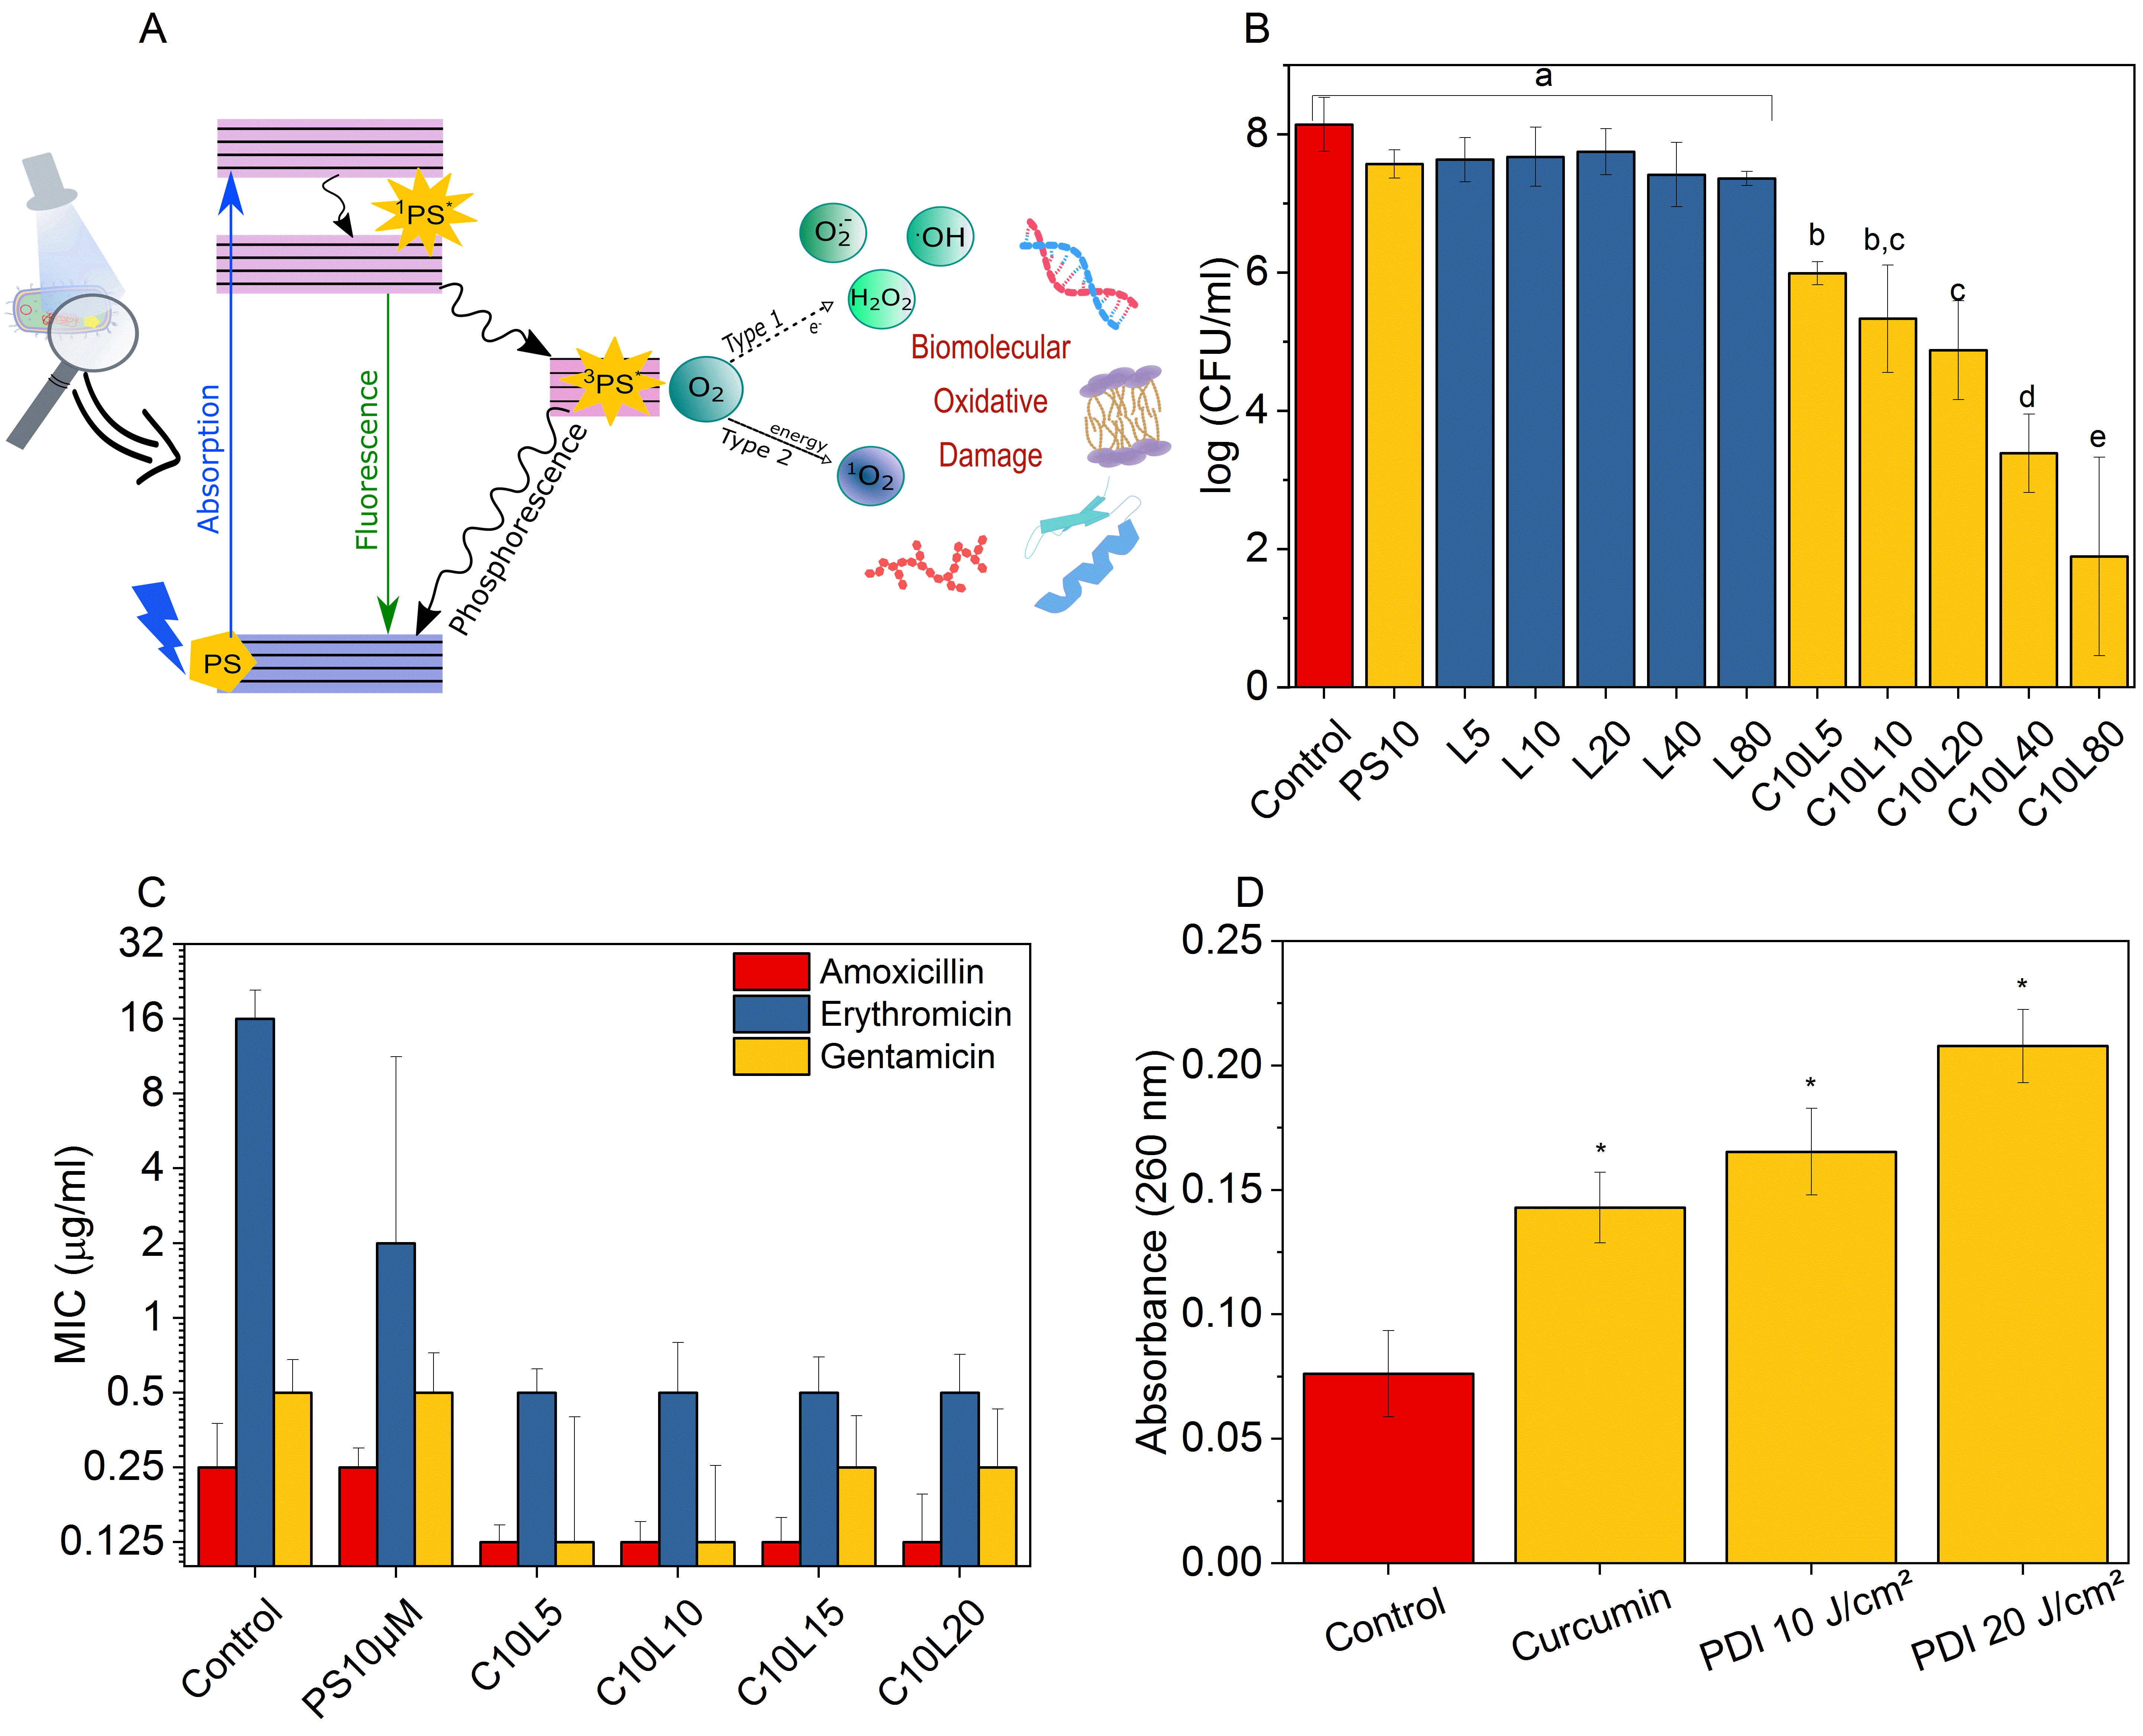
Figure 1 Photodynamic inactivation (PDI) and antibiotic therapy. A) Mechanism of action of the PDI represented by the Jablonski diagram. B) Survival of S. aureus with curcumin dark control 10 μM (PS10), control light doses from 5 to 80 J/cm³ (L) and PDI with fixed PS concentration for different light doses (C10L). B) Bacterial survival for PDI. C) Standard Minimum Inhibitory Concentration (MIC) (control) values for the antibiotic amoxicillin, erythromycin and gentamicin. D) Determination of membrane permeability by the presence of extracellular DNA in bacteria exposed to 10 μM of curcumin in the dark and with a light dose of 10 and 20 J/cm². * indicate statistically significant difference p<0.05.

Amoxicillin (β-lactam), erythromycin (macrolide) and gentamicin (aminoglycoside) shown in Figure 1.C presented the MIC indicating that the studied strain is sensitive to antibiotics, with the exception of erythromycin, which was classified as resistant. While antibiotic therapy has a specificity depending on the antibiotic used, which can be observed by the different MICs, the conditions of inactivation of the PDI are constant. The previous application of the PDI potentiated the action of the three antibiotics. Surviving microbial cells were more sensitive with a 2- to 32-fold reduction in MICs. Bacterial exposure to curcumin in the dark did not change the initial MIC values for AMO and GEN, and there was an 8-fold reduction in bacterial cell numbers when treated with ERY. Reductions in MIC values promoted by the PDI preview application, in general, remained constant independent of the dose of applied light. This result demonstrated that synergistic combinations can be identified depending on the treatment conditions and the class of antibiotic chosen.
To assess the damage caused to the bacterial plasma membrane by PDI, the presence of extracellular DNA was quantified. Figure 1.D shows the representation of the genetic material of the PDI groups in relation to the control group. The highest light dose (20 J/cm²) applied to the PDI showed a greater presence of extracellular DNA in the supernatant, indicating bacterial membrane damage due to the increase in its permeability.
EFFECT OF COMBINATION THERAPY PROTOCOLS - Different combined protocols of PDI with antibiotic therapy were evaluated for the influence of the order of combination of both therapies on inactivation responses. In Figure 2, the survival response of S. aureus is shown at different antibiotic concentrations close to the MIC value. The bacteria first receive the PDI then the antibiotic in the group oxidative stress. All treated groups showed lower survival when compared to monotherapies for the combination of ERY and GEN with PDI (only ANTB or PDI) i.e. a synergistic response. The groups treated with AMO combined with PDI (20 J/cm²) had lower survival than monotherapy, therefore some groups were synergistic. Whereas, microbial survival was higher compared to antibiotic therapy, but lower than PDI monotherapy using 10 J/cm² and higher concentrations of AMO.
In the protocol called simultaneous internalization, the ANTB is irradiated with the PS, that is, PS and ANTB are internalized simultaneously in the cells previously untreated. For AMO and ERY, most of the results were antagonistic, with a higher survival than the monotherapies, while the GEN presented synergistic and antagonistic results, mainly depending on the concentration of the antibiotic used, and the higher the concentration, the survival decreases for both applied light doses. In general, antibiotic irradiation in the simultaneous internalization protocol leads to mostly antagonistic results, as there are smaller reductions in bacterial mortality arising from the interaction between curcumin and antibiotics in order to reduce availability for antimicrobial action. These results demonstrate that not only the concentrations of antibiotics, but the PS and the light dose influence the achievement of synergistic results, but the protocol applied can be decisive.

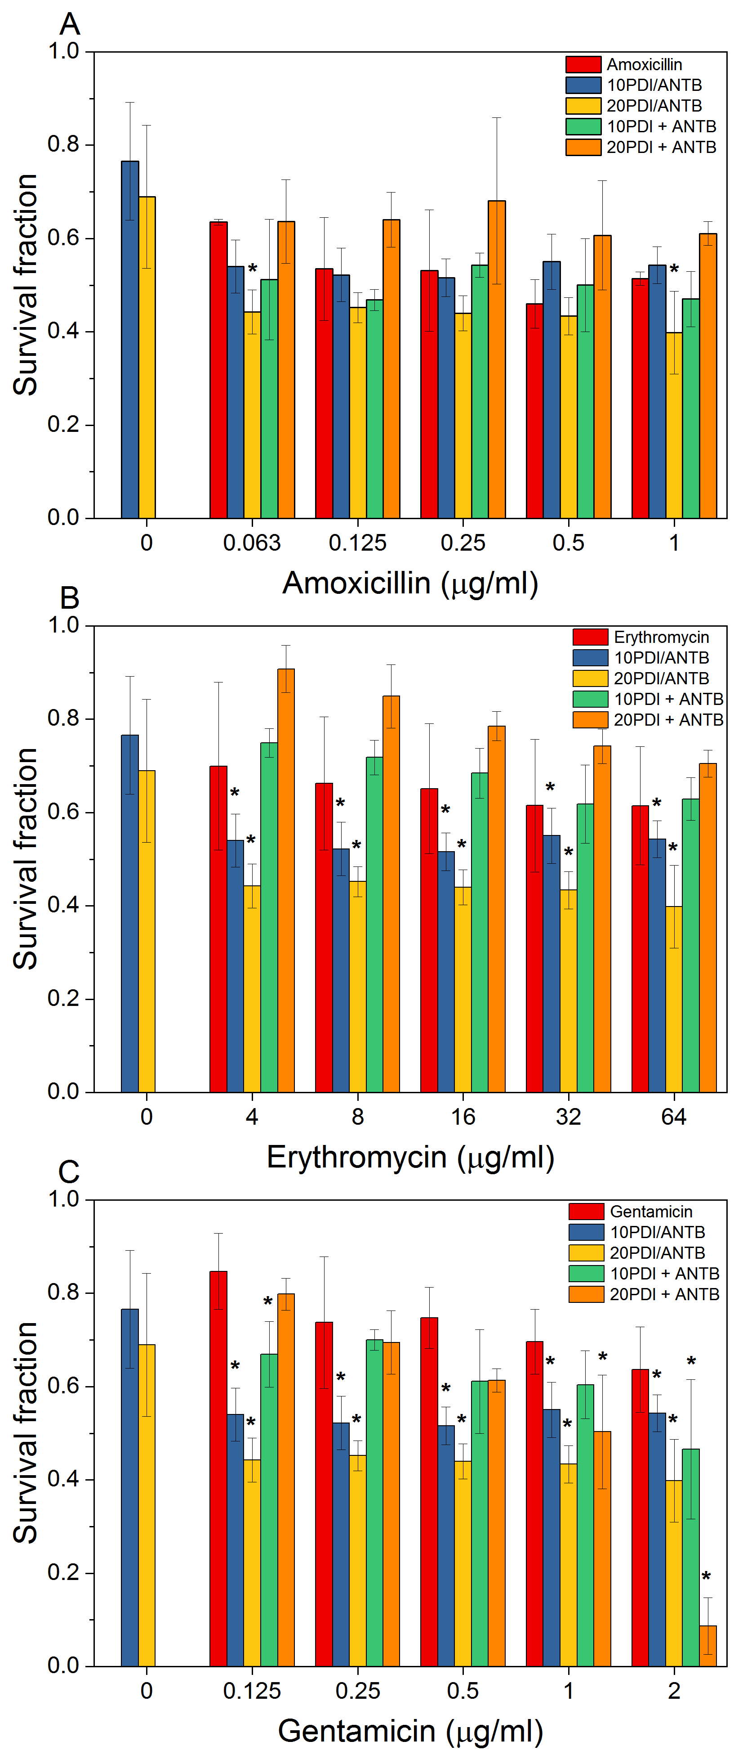
Figure 2 Survival curve of combined treatments by oxidative stress (PDI/ANTB) and Simultaneous internalization (PDI+ANTB), being applied 10 μM of curcumin and 10 and 20 J/cm². A) Amoxicillin, B) Erythromycin, C) Gentamycin. The normalizations are for untreated bacteria. * indicates synergistic combination for Bliss independence.
DYNAMICS OF BACTERIA INTERACTION WITH PHOTOSENSITIZERS AND ANTIBIOTICS
Based on the results of mostly antagonistic simultaneous internalization, the mechanism of curcumin and antibiotic interaction followed by irradiation was investigated using confocal fluorescence microscopy. In Figure 3.A shows the kinetics of incorporation of curcumin alone and with the presence of the antibiotics AMO, ERY and GEN. Comparatively, curcumin alone has a kinetic behavior distinct from the presence and absence of antibiotics. For curcumin alone, the initial concentration incorporated (t=0 min) is 40% lower, but the increase in incorporation is up to 2.5-fold, a proportion similar to the presence of antibiotics. The bacteria with CUR and ERY have an immediate internalization dynamic, while CUR alone and in the presence of AMO and GEN has a minimum time to start active incorporation, and over this time there are indications of a disturbance in the permeability control of the membrane, as the fluorescence intensity of internalized curcumin decreases.
In Figure 3.B, the photodegradation action of curcumin incorporated by the bacteria is more pronounced for curcumin alone, with a 1.75-fold decrease in fluorescence intensity than in the presence of antibiotic (Figure S1). This effect is related to photodegradation of PS resulting in the production of ROS, which is more prominent for curcumin alone, Figure 3.C-E. The recovery time of internalized curcumin with a maximum of 85% is 2.1 min, while in the presence of antibiotics the average recovery rate was approximately 70% in 0.4 min, being faster as expected considering that the presence of antibiotics facilitates the internalization of the PS, but does not necessarily favor the PDI. The low photodegradation of curcumin in the presence of antibiotics may be related to the decrease in ROS production, which is in agreement with the results shown above (Figure 2), since the simultaneous internalization protocol has a lower antimicrobial effect.
Figure 3 Confocal microscopy data of 10 μM curcumin fluorescence in S. aureus and with the presence of the antibiotics amoxicillin, erythromycin and gentamicin. A) Kinetics of curcumin incorporation. B) Fluorescence Recovery After Photodegradation (FRAP) of curcumin. Image of photodegradation of internalized curcumin with 63x magnification and channel mode with timelapse C) 1min7s D) 2min7s and E) 10min1s.
BACTERIAL RESPONSE TO TREATMENT CYCLE - In clinical practice, ANTBs are administered periodically, thus combining treatment cycles for 30 h were simulated, shown in Figure 4. PDI monotherapy in the first hours has a survival result equivalent to ANTB monotherapy, but over time PDI remains with the response constant while the survival of the antibiotic therapy group declines. Figure 4.A shows the survival of S. aureus in combined treatment consisted of alternating every 6 h between PDI and antibiotic therapy (PDI/ANTB). In the first hours the bacterial cells are more weakened due to the fast action of the PDI favoring the action of the ANTB presenting a lower survival when compared to the monotherapies. However, over time there was a greater survival of the bacteria treated with alternate therapies when compared to antibiotic therapy. That is, the result presented shows that alternating treatments for long periods is more effective when compared to PDI monotherapy, but antibiotic therapy is superior to these two protocols.
In Figure 4.B, the bacteria was treated with the combination of PDI and ANTB every 6 hours, using the oxidative stress protocol that proved to be more effective (PDI+ANTB). The result shows that the combination of therapies significantly reduces the survival of the bacteria compared to monotherapies, given that the mechanism of action of PDI is immediate in bacterial cells and the action of ANTBs is effective over time. The result of the concomitant cycle stands out as a better protocol, for example in time and 12 hs the PDI monotherapy has a reduction of bacterial survival of 20% and for ANTB an average of 21%, but for the concomitant cycle the reduction is on average of 52%, that is, the answer not an additive effect of the PDI and ANTB monotherapies, but superior.
Colonies surviving after 12 h of treatment cycles were submitted to FTIR spectroscopy to evaluate the effect of monotherapies and combinations on the vibrational bonds of biomolecules present on the bacterial cell surface, Figure 4.C-E. The region 900 – 1200 cm⁻¹ corresponds to carbohydrates, and as shown in Figure 4.F, it maintained a similarity of 50% with the control, the PDI, ERY and GEN monotherapy groups and the PDI+ERY combination. For the other combinations including AMO monotherapy, carbohydrates were different from controls. Regarding carbohydrates, it was observed that the only group that did not show any similarity with the control was monotherapy with GEN, an antibiotic that acts on protein synthesis, despite the PDI+GEN group having a similarity of approximately 80% with the control as shown in Figure 4.G. In Figure 4.H both groups do not share similarity with the control regarding fatty acids, and the AMO, PDI and PDI/GEN groups had a similarity of less than 50% with the control. In general, the application of any treatment, whether combined or monotherapy, affects the vibrational states of bacterial surface biomolecules.

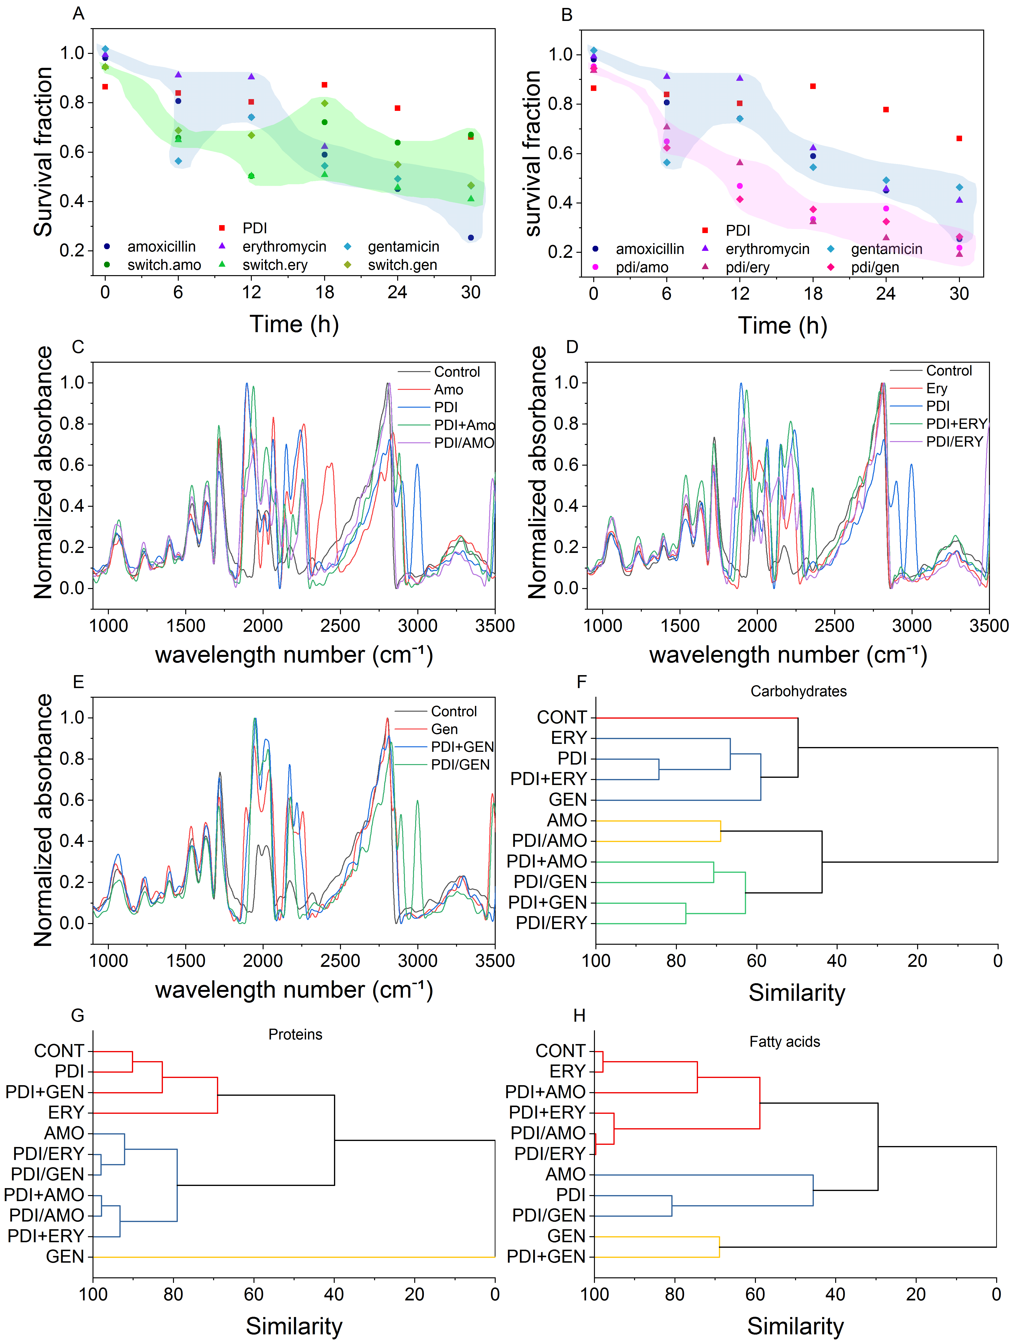
Figure 4 Treatment cycle. PDI with 10 μM of curcumin and 10 J/cm² colored red, antibiotic control group colored blue. The normalizations are for untreated bacteria. A) Combined treatment alternating every 6 hours starting with the PDI B) Combined treatment concomitant every 6 hours. FTIR absorbance spectrum of the surviving bacteria after 12 hours of the treatment cycle of the PDI, AMO, ERY and GEN monotherapies and the combined treatments sequentially every 6 hours (PDI+ANTB) and alternating every 6 hours starting (PDI/ANTB) for groups treated with C) amoxicillin, D) erythromycin, E) gentamicin. Hierarchical Cluster Analysis of the 2nd derivative of the FTIR absorption spectrum of the regions F) 900 – 1200 cm⁻¹ corresponding to carbohydrates, G) 1500-1800 cm⁻¹ corresponding to proteins e H) 2500 – 2800 cm⁻¹ corresponding to fatty acids. The colors of the dendrogram indicate the clustering of similarity greater than 50%.
4 - DISCUSSION
The resistant and persistent bacteria have increased significantly over the years, encouraging studies to potentiate the antibiotic's action. The mechanism action of antibiotics aims to inactivate essential processes for the maintenance and growth of the bacterial cell ¹⁹. Antibiotic resistant bacteria develop modification on drug binding sites, increasing the expression of efflux pumps or enzymes that degrade such molecules, it is of particular interest for combined therapies that act in another action mechanism and, in certain situations, may potentiate the drug action. The antibiotic effectiveness does not correspond only to the ligand-receptor interaction, as these also promote other metabolic responses²⁰, such as the increase in basal production of ROS reported for some bactericidal antibiotics of the β-lactam class and aminoglycosides ^{11,21,22}. Oxidative stress can be potentiated with the introduction of PDI in a combination treatment.
When PDI is applied before the antibiotic in sub-inhibitory conditions, damage to the membrane is caused, affecting its permeability. The curcumin has a predisposition to interact with the lipid bilayer and influences the dynamics of gramicidin channels ²³. The increase in membrane permeability may favor the internalization of the antibiotic, which is a prerequisite for its effectiveness ². In addition, the production of ROS promoted by the interaction of curcumin with blue light affects not only the membrane, but also the various cellular components, weakening or eliminating the bacterial cell ²⁴. It is evident, comparing both protocols, that the previous damage caused by sub PDI in the membrane and in the cellular metabolic processes weakens the bacteria, which makes it more susceptible to other antimicrobials. Therefore, the synergistic effect in the oxidative stress protocol was observed decreasing MIC values, a fact also demonstrated in other planktonic cultures² and biofilms²⁵
The synergistic or antagonistic responses are dependent on the different parameters of each applied monotherapy. Although both antimicrobial techniques are being combined, the activity is probably not performed simultaneously, but as a succession of factors. In this study, the simultaneous curcumin and AMO, ERY and GEN internalization was less efficient in bacterial inactivation than the oxidative stress protocol which potentialized the therapy. In this scenario, we assume that antibiotics exposed to irradiation can promote a disturbance in the medium although it does not correspond to its spectral region of absorption. Antibiotics can act together with biomolecules such as ROS, which may reduce the PDI effectiveness when incorporation results demonstrating a greater and faster cellular accumulation of curcumin (Figure S2, S3).
OH, O₂⁻, ¹O₂ from Fenton oxidation, photocatalytic oxidation, electrochemical oxidation has been promoted the oxidation and reduction of several classes of antibiotics in drinking water treatments, obtaining as reaction product compounds with preserved central structure and intermediates.^{27,28} Similarly, the antibiotic presence during the ROS production by PDI enables the same scenario promoted by oxidative processes (AOPs) and, occurring antibiotic degradation during the photodynamic action.
The efficiency of a PS can be modulated with the environment in which it is present. In the case of curcumin, as it is a mostly hydrophobic molecule, it is expected that in the aqueous environment the molecules will be aggregated as evidenced by the predominance of short lifetimes and the red shift in the emission spectrum, also observed in the presence of the antibiotic in aqueous medium (Figure S2). When PS molecules are internalized are free inside, having a greater efficiency in the production of ROS when compared to external molecules in solution. However, because the intracellular concentration is approximately in the millimolar order of magnitude, we hypothesized that the curcumin molecules are spatially distributed close to the energy transfer radius (Eq. S1-3). Thus, when a photon is absorbed, the efficiency of the energy transferred to oxygen molecules is decreased due to the increase of non-radioactive transfers between curcumin (Figure S3), thus decreasing the efficiency of PDI when compared to internalization of curcumin in lower concentration in the absence of antibiotics, which corresponds to the oxidative stress protocol.
By analyzing the time of curcumin fluorescence decay inside the microorganism, we note that this time is severely affected by the concentration conditions as well as the presence of antibiotics. The decay is different from a monoexponencial, as indicated by the nonlining of fluorescence curves. This indicates a situation that goes beyond the variation of the excited state with number represented by the excited molecules. It is initially observed that the non-saturated case always decreases more slowly in the saturated, demonstrating that the saturation regimen of the concentration (flow molecules entering equivalent to the flow of molecules leaving) washing a complex state of alteration of the environment for the curcumin molecule, which accelerates the transfer of energy by non-radioactive methods, accelerating the natural decay of the excited state. Because this behavior is related to the antibiotic, it suggests that such molecules have a fundamental participation in this process.
To better understand this behavior the s3 figure shows all the data observed, while S3.B-C show the observed behavior. From the point of view of influencing the life time of the excited state of curcumin, it is observed that I AMO is lower than the ERY, which in turn is less than GEN. This also demonstrates that this should be the order of curcumin interaction with the antibiotic molecules, that is GEN > ERY > AMO.
PDI has not promoted the selection of resistant bacteria even if sub inhibitory conditions of treatments are applied differently from antibiotic therapy ^{32,33}. PDI still has limitations resulting in low efficacy for infection treatment, mainly due to the PS incorporation and light penetration into infectious biological tissues. That is, any technique has advantages and disadvantages, so when combining therapies, in addition to aiming at potentiated antimicrobial results, one should seek to minimize the disadvantages, how is the case of PDI and antibiotic therapy. Furthermore, not only the inhibitory effects should be analyzed when implementing the combination of treatments, but also observing the effects on the structures of surviving cells, in addition to their metabolic activity.
Based on the results shown here, I was possible to verify that combined treatments resulted in efficiency responses superior than the monotherapies. It is evident that the combined use of PDI with different classes of antibiotics can results in different antimicrobial performance due to bacterial incorporation rate and vibrational states of biomolecules.

5- CONCLUSION
The present work demonstrates that PDI is capable of potentiating the action of ANTB when both are combined. The action of antibiotics occurs from the moment the molecules are internalized inside the cell, since the targets-action these drugs are in intracellular structures. The MIC reduction with previous PDI application demonstrated that cell damage, mainly in the membrane, affects cell permeability, favoring the antimicrobials uptake, in order to increase the antibiotic susceptibility by the bacteria, promising results in the perspective to reverse the scenario of resistant and persistent microorganisms.
It is noteworthy that different combination protocols of both therapies influence synergistic or antagonistic effects. The ROS produced by PDI can weaken the cell facilitating the action of antibiotics or degrade the antimicrobials decreasing their efficiency, as well as the antibiotic and photosensitizer interaction. may compromise photodynamic efficiency. Therefore, the previous application of PDI stands out as the best temporal sequence of combination of its studied therapies. Although the interaction between therapies may not present trivial results, the adjustment of the parameters allows enhance the antimicrobial action that can be applied in both sensitive and resistant strains, what would it be a solution to the challenge of antibiotic failure.

ACKNOWLEDGMENT: This work was supported by Coordenação de Aperfeiçoamento de Pessoal de Nível Superior (CAPES) (finance code 001), Center of Optics and Photonics CEPOF-FAPESP (2013/07276-1) and CNPQ INCT program (465360/2014-9), as well as FAPESP (2019/13569-8) financed this study in part.

Referências
1. Rowe, S. E. et al. Reactive oxygen species induce antibiotic tolerance during systemic Staphylococcus aureus infection. Nat. Microbiol. 5, 282–290 (2020).
2. Song, M. et al. A broad-spectrum antibiotic adjuvant reverses multidrug-resistant Gram-negative pathogens. Nat. Microbiol. 5, 1040–1050 (2020).
3. Maisch, T. A New Strategy to Destroy Antibiotic Resistant Microorganisms: Antimicrobial Photodynamic Treatment. Mini-Reviews Med. Chem. 9, 974–983 (2009).
4. Yadav, S. et al. Making of water soluble curcumin to potentiate conventional antimicrobials by inducing apoptosis-like phenomena among drug-resistant bacteria. Sci. Rep. 10, 1–22 (2020).
5. Blair, J. M. A., Webber, M. A., Baylay, A. J., Ogbolu, D. O. & Piddock, L. J. V. Molecular mechanisms of antibiotic resistance. Nat. Rev. Microbiol. 13, 42–51 (2015).
6. Peterson, E. & Kaur, P. Antibiotic resistance mechanisms in bacteria: Relationships between resistance determinants of antibiotic producers, environmental bacteria, and clinical pathogens. Front. Microbiol. 9, 1–21 (2018).
7. Wozniak, A. & Grinholc, M. Combined Antimicrobial Activity of Photodynamic Inactivation and Antimicrobials–State of the Art. Front. Microbiol. 9, (2018).
8. Wainwright, M. et al. Photoantimicrobials—are we afraid of the light? Lancet Infect. Dis. 17, e49–e55 (2017).
9. Bacellar, I., Tsubone, T., Pavani, C. & Baptista, M. Photodynamic Efficiency: From Molecular Photochemistry to Cell Death. Int. J. Mol. Sci. 16, 20523–20559 (2015).
10. Hamblin, M. R. & Hasan, T. Photodynamic therapy: a new antimicrobial approach to infectious disease? Photochem. Photobiol. Sci. 3, 436 (2004).
11. Brynildsen, M. P., Winkler, J. A., Spina, C. S., MacDonald, I. C. & Collins, J. J. Potentiating antibacterial activity by predictably enhancing endogenous microbial ROS production. Nat. Biotechnol. 31, 160–165 (2013).
12. Elsevier. Penicillins Comparative studies Penicillins versus carbapenems Penicillins versus monobactams. (2016). doi:10.1016/B978-0-444-53717-1.01237-3
13. Majer, J. Macrolide Antibiotics. in Journal of Chromatography Library 15, 273–308 (1978).
14. Studies, D. & Information, G. Aminoglycoside antibiotics Observational studies and reactions Neuromuscular function. (2016). doi:10.1016/B978-0-444-53717-1.00270-5
15. Clinical and Laboratory Standards Institute. Performance Standards for Antimicrobial Susceptibility Testing; Fifteenth Informational Supplement. 25, (2005).
16. Siriwong, S., Teethaisong, Y., Thumanu, K., Dunkhunthod, B. & Eumkeb, G. The synergy and mode of action of quercetin plus amoxicillin against amoxicillin-resistant Staphylococcus epidermidis. BMC Pharmacol. Toxicol. 17, 1–14 (2016).
17. Webber, J., Kessel, D. & Fromm, D. Side effects and photosensitization of human tissues after aminolevulinic acid. J. Surg. Res. 68, 31–37 (1997).
18. Courtney, C. M. et al. Potentiating antibiotics in drug-resistant clinical isolates via stimuli-activated superoxide generation. Sci. Adv. 3, 1–11 (2017).
19. Pontes, M. H. & Groisman, E. A. Slow growth dictates non-heritable antibiotic resistance in Salmonella enterica. Sci. Signal. 12, (2019).
20. Zou, L. et al. Synergistic antibacterial activity of silver with antibiotics correlating with the upregulation of the ROS production. Sci. Rep. 8, 1–11 (2018).
21. Vatansever, F. et al. Antimicrobial strategies centered around reactive oxygen species - bactericidal antibiotics, photodynamic therapy, and beyond. FEMS Microbiology Reviews 37, 955–989 (2013).
22. Takahashi, N. et al. Lethality of MalE-LacZ hybrid protein shares mechanistic attributes with oxidative component of antibiotic lethality. Proc. Natl. Acad. Sci. U. S. A. 114, 9164–9169 (2017).
23. Ingolfsson, H. I., Koeppe, R. E. & Andersen, O. S. Curcumin is a modulator of bilayer material properties. Biochemistry 46, 10384–10391 (2007).
24. Dias, L. D., Blanco, K. C., Mfouo-Tynga, I. S., Inada, N. M. & Bagnato, V. S. Curcumin as a photosensitizer: From molecular structure to recent advances in antimicrobial photodynamic therapy. J. Photochem. Photobiol. C Photochem. Rev. 45, 100384 (2020).
25. Ronqui, M. R., De Aguiar Coletti, T. M. S. F., De Freitas, L. M., Miranda, E. T. & Fontana, C. R. Synergistic antimicrobial effect of photodynamic therapy and ciprofloxacin. J. Photochem. Photobiol. B Biol. 158, 122–129 (2016).
26. Wang, J. & Zhuan, R. Degradation of antibiotics by advanced oxidation processes: An overview. Sci. Total Environ. 701, 135023 (2020).
27. Ge, L. et al. The importance of reactive oxygen species on the aqueous phototransformation of sulfonamide antibiotics: kinetics, pathways, and comparisons with direct photolysis. Water Res. 149, 243–250 (2019).
28. Jeong, J., Song, W., Cooper, W. J., Jung, J. & Greaves, J. Degradation of tetracycline antibiotics: Mechanisms and kinetic studies for advanced oxidation/reduction processes. Chemosphere 78, 533–540 (2010).
29. Blanco, K. C. PDT, an Adjuvant Therapy to Antibiotic Failure in Streptococcal Tonsillopharyngitis. Biomed. J. Sci. Tech. Res. 6, 001–003 (2018).
30. Kassab, G. et al. Safety and delivery efficiency of a photodynamic treatment of the lungs using indocyanine green and extracorporeal near infrared illumination. J. Biophotonics 13, (2020).
31. Zangirolami, A. C., Inada, N. M., Bagnato, V. S. & Blanco, K. C. Biofilm Destruction on Endotracheal Tubes by Photodynamic Inactivation. Infect. Disord. - Drug Targets 18, 218–223 (2018).
32. Soares, J. M., Inada, N. M., Bagnato, V. S. & Blanco, K. C. Evolution of surviving Streptoccocus pyogenes from pharyngotonsillitis patients submit to multiple cycles of antimicrobial photodynamic therapy. J. Photochem. Photobiol. B Biol. 210, 111985 (2020).
33. Kashef, N. & Hamblin, M. R. Can microbial cells develop resistance to oxidative stress in antimicrobial photodynamic inactivation? Drug Resist. Updat. 31, 31–42 (2017).

